Kevin Murray
Adventure Works Project 4 Changes
Slide 1 (Title Slide):
I changed my title from “Understanding Adventure Works” to “Buy Adventure Works”. This takes a clear stance on what my opinion is for the client.
On my first bullet point I added “Australia Down” to give a better description of what to look for or keep in mind for the presentation and on the first slide.
BEFORE:
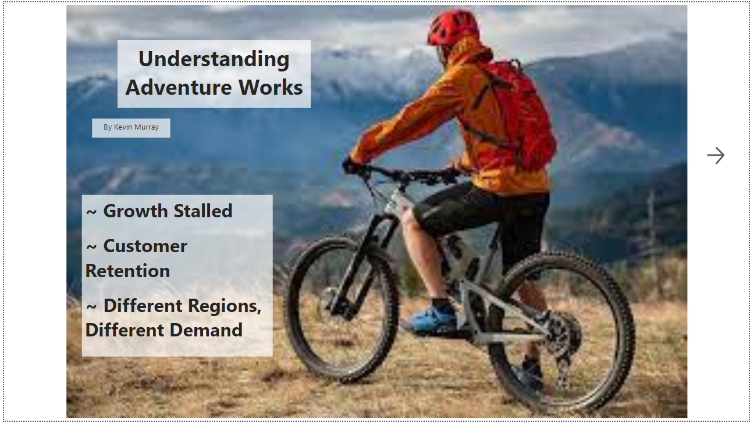
AFTER:
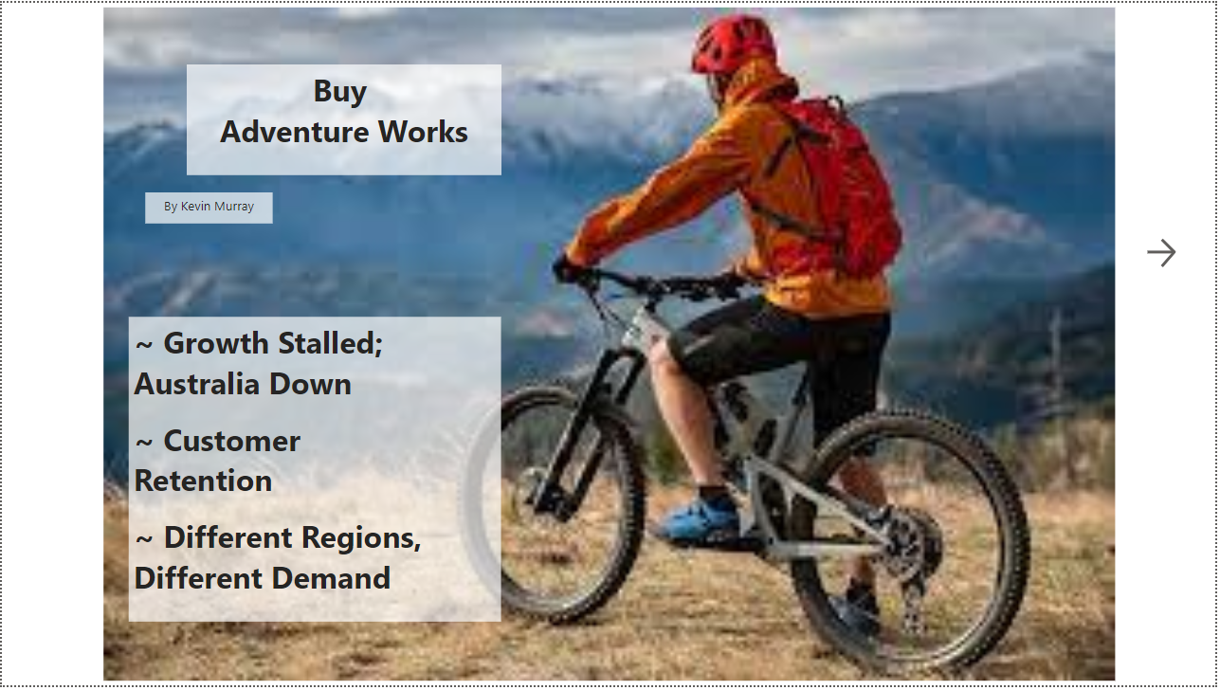

Slide 2 (Growth Stalled):
Changed the title to the slide to provide a better insight. I removed Cost of Goods sold from being shown in my graphic. This allows it to be more focused on what the insight is trying to convey.
BEFORE:
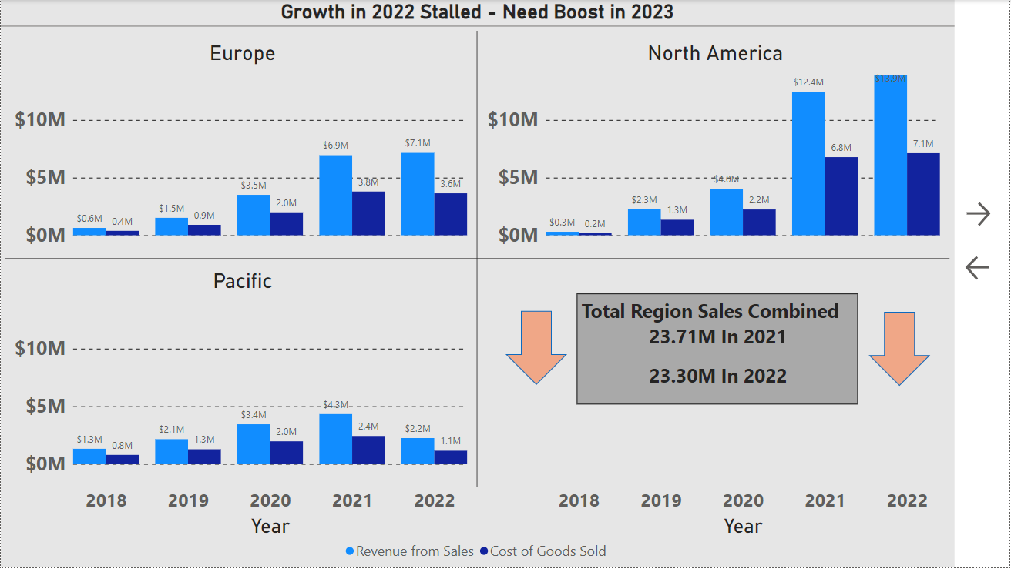
AFTER:
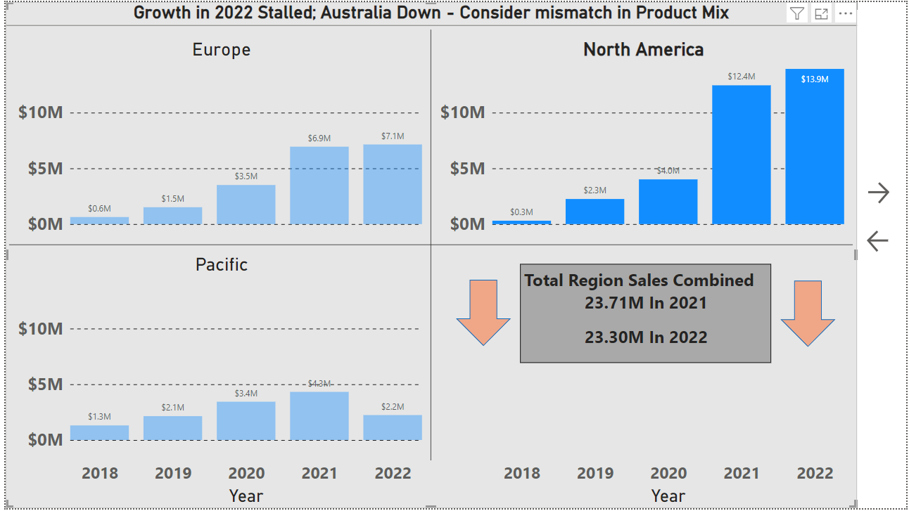

Slide 3 (Customer Retention):
I combined all the data into 2 data points, 2021 and 2022, instead of by region and by year. Given the small differences between regions, combining the data makes the slide less busy, but still conveys our insight and data in an accurate way. I added call outs showing percentages to better convey the data.
BEFORE:
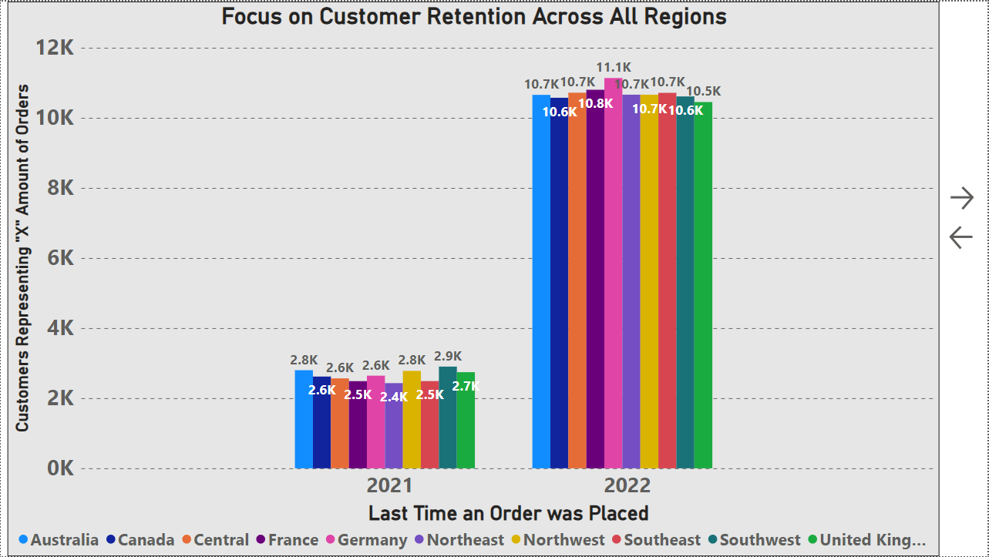
AFTER:
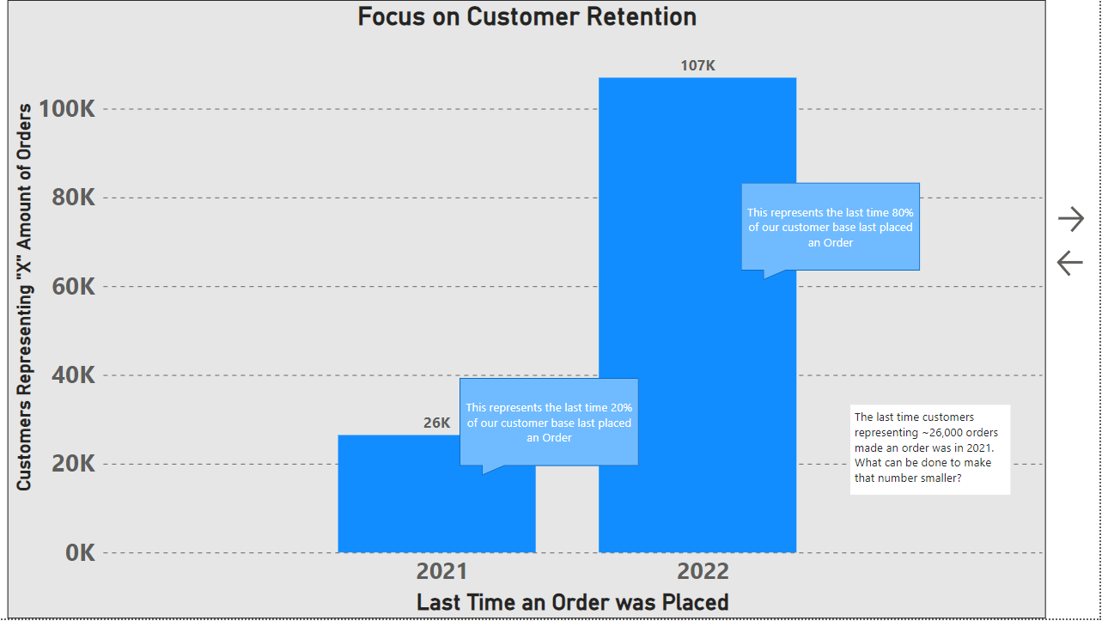

Slide 4 (Promotion):
I did my best to change the way I present my findings. I rephrased my Insight. I changed the graphic, changed the title on the y-axis, I sorted the data by Year as well as by Product. I initially wanted to add the year but found that if I had it by year it became too “busy”, but with this graphic I think it shows that change a little better.
BEFORE:
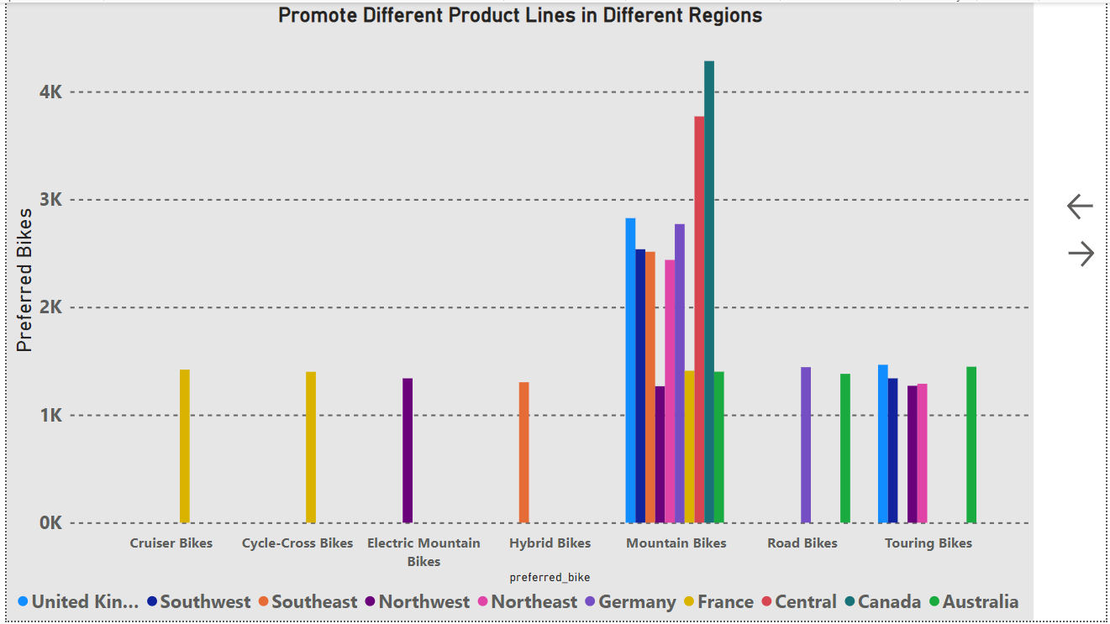

AFTER:
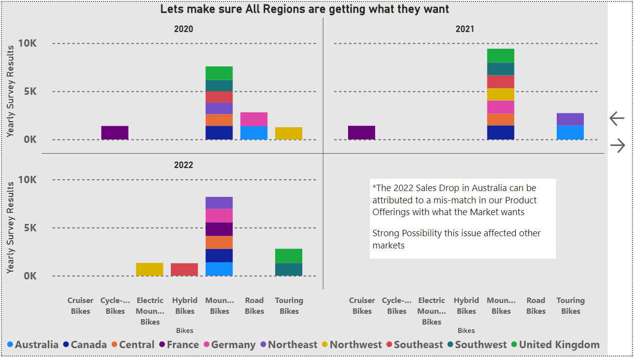

Slide 5 (Dashboard):
I didn’t make any changes on this slide as the initial feedback given was that it “Looks good” and nothing else was noted. However, given what my deck focuses on, I think I would drop the COGS and maybe try to add another filter or another image/graphic that might help support the data I’m conveying on each of my slides such as Customer Orders each year, or market survey results.
